

SAVEETHA SCHOOL OF ENGINEERING
SAVEETHA INSTITUTE OF MEDICAL AND TECHNICAL SCIENCES
CHENNAI-602105

Intelligent Emergency Vehicle Priority System for Driveway Traffic Control
Submitted in the partial fulfilment for the award of the degree
of
BACHELOR OF ENGINEERING IN ELECTRONICS AND COMMUNICATION ENGINEERING
Submitted by
Student name:
E.SHASHANK NARAYANA - 192312507
M.YUGANDHAR REDDY – 192372016
P.MAL REDDY – 192372015
P.SRAVANI – 192311135
E.ATHISH – 192371015

COURSE: EEA0117 – BASIC ELECTRICAL AND ELECTRONICS ENGINEERING FOR HOME AUTOMATION
Under the Supervision of
Dr. Valantina Stephen, Dr. R. Sivakumar
SUBMITTED ON 29-01-2026
SAVEETHA SCHOOL OF ENGINEERING
SAVEETHA INSTITUTE OF MEDICAL AND TECHNICAL SCIENCES
CHENNAI-602105

DECLARATION
We SAVEETHA INSTITUTE OF MEDICAL AND TECHNICAL SCIENCES CHENNAI-602105 DECLARATION E.Shashank Narayana-192312507,M.Yugandhar Reddy-192372016,P.Mal Reddy-192372915,P.Sravani-192311135,E.Athish-192371015 student of ‘ Bachelor of Engineering in Electronics and Communication Engineering, SIMATS, Saveetha University, Chennai, hereby we declare that the work presented in this Capstone Project Work entitled title is the outcome of our Bonafide work and is correct to the best of our knowledge and this work has been undertaken taking care of Engineering Ethics.
E.SHASHANK NARAYANA - 192312507
M.YUGANDHAR REDDY – 192372016
P.MAL REDDY – 192372015
P.SRAVANI – 192311135
E.ATHISH – 192371015

Date:29-01-2026
Place: SSE
SAVEETHA SCHOOL OF ENGINEERING
SAVEETHA INSTITUTE OF MEDICAL AND TECHNICAL SCIENCES
CHENNAI-602105

BONAFIDE CERTIFICATE
Certified that this capstone project report of Intelligent Emergency Vehicle Priority System for Driveway Traffic Control who carried out the capstone project work under our supervision for the course EEA0117 – Basic Electrical and Electronics Engineering for Home Automation.
SIGNATURE
Dr. Valantina Stephen Dr. R. Sivakumar
Submitted for the Project work Viva-Voce held on 31/01/2026
INTERNAL EXAMINER EXTERNAL EXAMINER
ABSTRACT
Rapid and safe movement of emergency vehicles is critical in saving lives, yet traffic congestion at driveways and intersections often causes significant delays. This paper presents an Intelligent Emergency Vehicle Priority System for Driveway Traffic Control that dynamically detects approaching emergency vehicles and grants them priority passage by intelligently controlling driveway traffic signals.
The proposed system uses real-time data from sensors and communication modules to identify authorized emergency vehicles such as ambulances, fire engines, and police vehicles. Once detected, the system automatically adjusts traffic flow by clearing driveway entries, extending green signals, and restricting non-emergency vehicle movement. The system also minimizes disruption to regular traffic by restoring normal operation immediately after the emergency vehicle passes.
Simulation and experimental results demonstrate that the proposed approach significantly reduces response time, improves traffic efficiency, and enhances road safety. This intelligent and automated solution is cost-effective, scalable, and suitable for smart city traffic management systems.

KEYWORDS:
- Intelligent Traffic Management
- Emergency Vehicle Priority
- Smart Traffic Signals
- Real-Time Traffic Control
- Internet of Things (IoT)
- Embedded Systems
- Smart City Infrastructure
TABLE OF CONTENTS
Section | Page Number
Abstract | 4
Table of Contents | 5
Chapter 1: Introduction | 6
Chapter 2: Problem Identification and Analysis | 10
Chapter 3: Solution Design and Implementation | 13
Chapter 4: Results and Recommendations | 15
Chapter 5: Reflection on Learning and Personal Development | 18
Chapter 6: Conclusion | 20
References | 21
Appendices | 19

LIST OF FIGURES & TABLES

S.NO | NAME | PAGE NO
1 | Product Visual | 17
2 | Presentation Visual | 17
3 | SYSTEM DESIGN | 14

ACKNOWLEDGEMENTS
We grateful to the Chancellor of SIMATS Engineering, Dr. N.M.Veeraiyan, and Vice Chancellor Dr. Ashwini Kumar for motivating us to carry out research in the SIMATS Engineering and also for providing us with infrastructural facilities and many other resources needed for our research.

We sincerely thank the Director of Academics, Dr. Deepak Nallasamy for his visionary thoughts and support. We express our sincere thanks to Dr. Ramya Mohan Deepak, Director, and Dr. B. Ramesh, Principal, SIMATS Engineering for their kind words of support and encouragements.

With immense pleasure and a deep sense of gratitude, we wish to express our sincere thanks to our supervisors Dr. Valantina Stephen, Assistant Professor, Department of Electrical and Electronics Engineering and Dr. R. Sivakumar, Professor, Department of Electronics and Communication Engineering, SIMATS Engineering for their motivation and continuous encouragement, this work would not have been successfully completed.
We would like to thank our HOD, all staff members, members of research department who were always there at need of the hour and provided the facilities, which we required for the completion of the work.

We would like to express our deep appreciation to our parents, as well as our extended family, for their unwavering prayers and sacrifices throughout our journey. We would like to thank God for not letting us down at the time of crisis and guided us on right direction

Chapter 01

INTRODUCTION

1.1 Background Information
Efficient traffic management is a critical requirement for ensuring quick and safe movement of emergency vehicles such as ambulances, fire engines, and police vehicles. In many residential complexes, hospitals, and private driveways, emergency vehicles often face unnecessary delays due to manually operated or non-intelligent traffic control systems. These delays can significantly affect emergency response time, which is crucial in life-threatening situations.
Traditional traffic control systems operate on fixed timing mechanisms and lack the ability to dynamically prioritize emergency vehicles. With advancements in embedded systems, wireless communication, and automation technologies, intelligent traffic control solutions can be developed to detect emergency vehicles in real time and provide them with immediate traffic priority. This project leverages microcontroller-based automation, sensors, and RF communication to create an efficient emergency vehicle priority system.
1.2 Project Objectives
The primary objectives of this capstone project are:
• To design and develop an intelligent system that detects approaching emergency vehicles in real time.
• To provide automatic traffic priority at residential driveways and private road intersections.
• To reduce emergency vehicle waiting time and improve response efficiency.
• To minimize the need for manual traffic control and human intervention.
• To enhance overall traffic flow safety and operational efficiency.
1.3 Significance
Emergency response efficiency directly impacts public safety and survival rates during critical situations. Delays caused by traffic congestion at driveways or private junctions can lead to severe consequences. This project addresses this issue by introducing an automated emergency vehicle priority mechanism.
The proposed system contributes to intelligent traffic management by integrating embedded systems, sensors, and wireless communication. It offers a cost-effective and scalable solution suitable for residential complexes, hospitals, and controlled traffic environments. By automating traffic signal control, the system reduces human error, improves safety, and ensures faster emergency vehicle passage.
1.4 Scope
• Detection of emergency vehicles using sound sensors and RF communication.
• Automatic traffic signal control using a microcontroller-based system.
• Priority allocation to emergency vehicles at four-way junctions or driveways.
• Restoration of normal traffic flow after the emergency vehicle passes.
Not Included:
• City-wide traffic management or large-scale highway implementation.
• GPS-based or camera-based vehicle detection systems.
• Handling multiple emergency vehicles arriving simultaneously.
• Integration with cloud platforms or mobile applications.
1.5 Methodology Overview
This project follows a structured and systematic approach consisting of the following stages:
• Emergency Vehicle Detection: Detecting approaching emergency vehicles using sound sensors and RF transmitters.
• Signal Transmission: Sending detection signals wirelessly to the traffic control unit.
• Control Processing: Processing the received signal using a microcontroller to identify vehicle direction.
• Traffic Signal Override: Automatically overriding normal traffic signals to provide a green signal or open the driveway gate.
• System Restoration: Restoring normal traffic signal operation once the emergency vehicle has passed.
• Result Analysis: Evaluating system performance in terms of response time reduction and traffic flow efficiency.

CHAPTER 02

PROBLEM IDENTIFICATION AND ANALYSIS

2.1 Description of the Problem
Emergency vehicles such as ambulances, fire engines, and police vehicles frequently experience delays while passing through residential driveways, parking exits, and private road intersections. These delays occur due to the absence of intelligent traffic control mechanisms capable of recognizing emergency situations and dynamically prioritizing traffic flow. Conventional traffic systems typically operate on fixed timing schedules or rely on manual intervention, which is inefficient during critical emergencies.
The problem becomes more severe in controlled environments like hospitals, gated communities, and private complexes, where traffic signals or gates are not integrated with emergency response systems. Lack of real-time emergency vehicle detection leads to congestion, increased response time, and potential risk to human life. Existing systems do not adapt automatically to emergency scenarios and often depend on human traffic controllers, who may not be available at all times.
This project addresses the need for an automated, intelligent traffic control solution that can detect approaching emergency vehicles and provide them with immediate right-of-way. By integrating sensors, RF communication, and microcontroller-based control, the proposed system aims to reduce delays and ensure safe, fast, and efficient passage for emergency vehicles.

2.2 Evidence of the Problem
Several real-world factors highlight the seriousness of emergency vehicle delays:
• Traffic Congestion at Driveways: Residential complexes and hospital exits often experience peak-hour congestion, blocking emergency vehicles from immediate passage.
• Lack of Emergency Detection: Conventional traffic signals cannot differentiate between normal and emergency vehicles, resulting in unnecessary waiting time.
• Manual Traffic Control Limitations: Human-operated systems are prone to delays, errors, and availability issues, especially during night hours or emergencies.
• Signal Timing Constraints: Fixed-time traffic signals do not adapt to emergency situations, leading to inefficient traffic flow.
• Increasing Urbanization: Rapid urban growth has increased vehicle density, making emergency vehicle movement more difficult without intelligent control systems.
These issues demonstrate the urgent need for automated emergency vehicle prioritization systems in modern traffic environments.

2.3 Stakeholders
The implementation of an Intelligent Emergency Vehicle Priority System benefits multiple stakeholders, including:
• Emergency Services: Ambulance, fire, and police departments benefit from reduced response time and improved operational efficiency.
• Hospitals and Healthcare Facilities: Ensure faster arrival of patients and emergency vehicles, improving patient survival rates.
• Residential and Commercial Complexes: Improve safety and traffic management at private driveways and gated entrances.
• Traffic Authorities: Gain an automated and reliable traffic control mechanism that minimizes human intervention.
• Public and Road Users: Experience improved traffic discipline and reduced congestion during emergency situations.
• Engineers and Researchers: Provide a foundation for further research in intelligent traffic systems and smart city applications.

2.4 Supporting Data / Research
• Emergency Response Studies: Research indicates that even a delay of a few minutes in emergency response can significantly affect survival rates, particularly in medical emergencies.
• Intelligent Traffic Systems: Studies on RF-based and sensor-based traffic control systems have shown effective reduction in emergency vehicle waiting time.
• Embedded System Advancements: Microcontroller-based traffic control systems offer reliable, low-cost, and scalable solutions for real-time applications.
• Real-world Implementations: Several smart traffic projects have demonstrated successful emergency vehicle prioritization using RFID, RF communication, and sound sensors.
• Emerging Trends: Integration of IoT, GPS tracking, and AI-based vehicle detection is becoming increasingly popular in next-generation traffic management systems.
By adopting an embedded system-based intelligent control approach, this project provides a practical and cost-effective solution to a real-world problem, addressing the limitations of conventional traffic systems and improving emergency response efficiency.

Chapter 03

Solution Design and Implementation

3.1 Development and Design Process
The development of the Intelligent Emergency Vehicle Priority System followed a systematic engineering approach to ensure reliable and real-time operation. Initially, the traffic-related challenges faced by emergency vehicles at driveways and controlled intersections were analyzed to understand system requirements. Based on this analysis, an automated solution capable of detecting emergency vehicles and controlling traffic signals was planned.
The system architecture was then designed by selecting suitable hardware components such as sensors, RF communication modules, and a microcontroller. Circuit connections were implemented to enable communication between detection units and traffic signal controllers. Embedded programming was carried out using Arduino to process sensor inputs, manage wireless signals, and override normal traffic operation during emergency situations. Finally, the complete system was tested under different operating conditions to verify accurate detection, correct signal switching, and safe restoration of normal traffic flow.
- Evaluation and Validation: Testing the model on unseen data, assessing accuracy, and fine-tuning based on performance metrics.
- Deployment and Integration: Implementing the trained model into a user-friendly interface for real-world use.

3.2 Tools and Technologies Used
The implementation of the system involved the following tools and technologies:
• Microcontroller Platform: Arduino Uno for central control and decision-making
• Programming Environment: Arduino IDE for developing and uploading embedded code
• Detection Components: Sound sensor for siren identification
• Communication Technology: RF transmitter and receiver modules for wireless signaling
• Output Interfaces: Traffic signal LEDs and LCD display for system status indication
• Power Source: Regulated DC power supply
• Design and Testing Support: Breadboard and connecting wires for hardware integration

3.3 Solution Overview
The proposed solution operates by continuously monitoring the presence of emergency vehicles through sensor-based detection. When an emergency siren is detected, the RF transmitter sends a signal to the control unit installed at the driveway or traffic junction. The Arduino microcontroller processes this information and determines the direction of the approaching emergency vehicle.
Based on this decision, the system automatically interrupts the regular traffic signal sequence and activates a green signal in the emergency vehicle’s path, while blocking traffic in all other directions. An LCD module displays the emergency status and active signal direction for monitoring purposes. Once the emergency vehicle has passed, the system safely resumes normal traffic signal operation. This automated process ensures fast, efficient, and safe passage of emergency vehicles without manual intervention.

3.4 Engineering Standards Applied
To maintain system quality and safety, recognized engineering principles and standards were considered during development:
* Embedded System Design Standards: Ensured real-time responsiveness and stable operation
* Wireless Communication Guidelines: Followed to ensure reliable short-range RF data transmission
* Safety-Oriented Control Design: Applied to prevent signal conflicts during emergency overrides
* ISO/IEC 25010 Quality Model: Considered for system reliability, maintainability, and performance efficiency.
3.5 Solution Justification
The inclusion of engineering standards enhances:
- Reliability: Ensures consistent model performance across different datasets.
- Scalability: Allows integration into various applications without significant modifications.

SYSTEM DESIGN

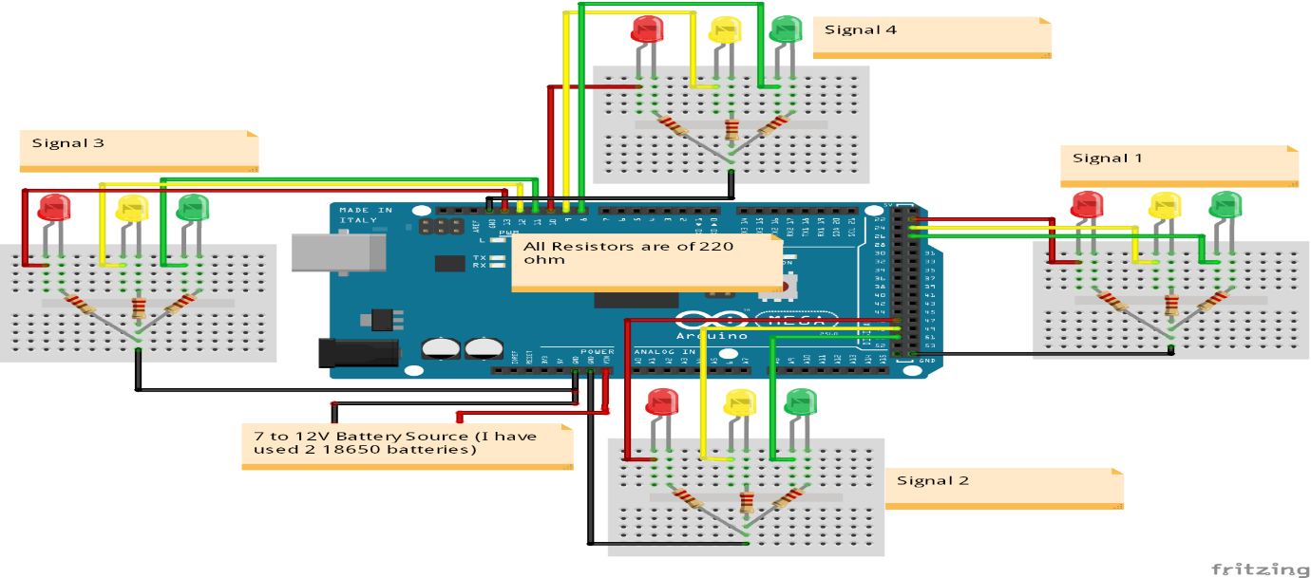

Chapter 04

Results and Recommendations
4.1 Evaluation of Results
The implemented Intelligent Emergency Vehicle Priority System was tested under controlled conditions to evaluate its performance and reliability. The system successfully detected emergency vehicle sirens and RF signals in real time and provided immediate traffic priority at the driveway junction. During testing, the microcontroller accurately processed detection signals and activated the appropriate traffic signal direction.
The performance of the system was evaluated based on the following parameters:
• Detection Accuracy: The system reliably detected emergency vehicle sirens within the defined sensor range.
• Response Time: Traffic signal override occurred almost instantly after emergency detection, reducing waiting time.
• Signal Control Efficiency: The correct traffic signal turned GREEN while all other directions remained RED.
• System Stability: Normal traffic operation was restored smoothly after the emergency vehicle passed.
• Display Feedback: The LCD correctly displayed emergency status and active signal direction for monitoring.
The results indicate that the system effectively improves emergency vehicle movement and enhances traffic flow safety in controlled environments.

4.2 Challenges Encountered
During development and testing, the following challenges were identified:
• False Triggering of Sound Sensors: Loud horns or non-emergency sirens occasionally activated the system.
Solution: Sensor sensitivity was adjusted and RF confirmation was used to improve detection reliability.
• Limited RF Communication Range: Signal strength reduced in the presence of physical obstacles or interference.
Solution: Proper antenna positioning and testing within controlled range conditions were implemented.
• Single Emergency Handling: The system could prioritize only one emergency vehicle at a time.
Solution: The limitation was documented for future enhancement using advanced communication methods.
• Environmental Dependency: Sensor performance varied depending on ambient noise levels.
Solution: Calibration was performed to ensure stable operation in typical traffic conditions.

4.3 Possible Improvements
The system can be enhanced further through the following improvements:
• GPS-Based Detection: Integrating GPS modules for precise and reliable emergency vehicle identification.
• AI-Based Siren Recognition: Using machine learning algorithms to differentiate emergency sirens from normal traffic noise.
• IoT Integration: Connecting multiple junctions to a centralized traffic monitoring system.
• Multi-Vehicle Handling: Designing algorithms to manage multiple emergency vehicles simultaneously.
• Energy Optimization: Incorporating solar power to improve sustainability and reduce power dependency.

4.4 Recommendations
Based on the project outcomes, the following recommendations are proposed:
• Extended Field Testing: Conduct real-time testing in larger residential or hospital environments.
• Collaboration with Traffic Authorities: To evaluate practical feasibility and scalability.
• Advanced Sensor Fusion: Combining sound, RF, and camera-based detection for higher accuracy.
• Smart City Deployment: Integrating the system into smart traffic infrastructure projects.
• Safety Certification: Adhering to stricter traffic safety standards before large-scale deployment.

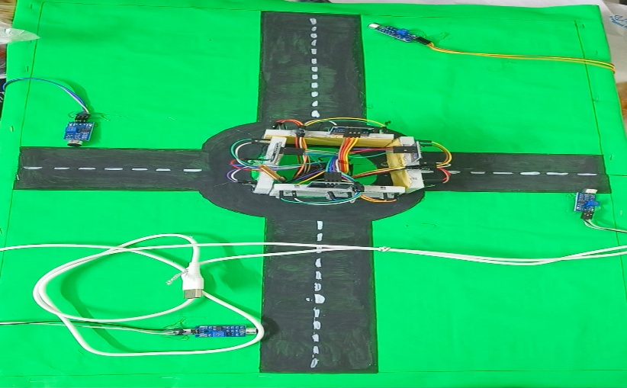



Chapter 05

Reflection on Learning and Personal Development

5.1 Academic Knowledge
This capstone project significantly enhanced my understanding of embedded systems, traffic control mechanisms, and real-time automation concepts. Through the design and implementation of an Intelligent Emergency Vehicle Priority System, I gained practical knowledge of microcontrollers, sensor-based detection, and wireless communication. The project helped me understand how theoretical concepts from electrical and electronics engineering can be applied to solve real-world traffic management problems.
5.2 Technical Skills
During the course of this project, I developed and strengthened the following technical skills:
• Embedded Programming: Improved proficiency in Arduino programming for real-time control applications.
• Hardware Interfacing: Gained experience in interfacing sound sensors, RF modules, LEDs, and LCD displays with microcontrollers.
• Circuit Design: Learned practical aspects of circuit integration, power management, and component interfacing.
• System Testing: Developed skills in testing and debugging hardware and software components to ensure reliable operation.
5.3 Problem-Solving and Critical Thinking
The project involved addressing several technical challenges such as false sensor triggering, communication limitations, and timing synchronization of traffic signals. I learned to analyze system behavior logically and implement effective solutions through sensor calibration, code optimization, and systematic testing. This experience strengthened my ability to troubleshoot real-time embedded systems and make informed engineering decisions.

5.4 Personal and Professional Growth
One of the major challenges was ensuring accurate emergency vehicle detection under varying environmental conditions. Initially, the system responded to non-emergency noises, but this was resolved through sensitivity adjustment and controlled signal processing. The project improved my confidence in handling hardware-based systems and enhanced my ability to manage time, plan development stages, and deliver a functional engineering solution.
5.5 Collaboration and Communication
Although the project was primarily individual, guidance from faculty members and discussions with peers played an important role in refining the system design and implementation. I learned the importance of documenting design choices and explaining technical concepts clearly. If implemented in a team environment, structured communication and clear task distribution would further improve efficiency and collaboration.
5.6 Application of Engineering Standards
Engineering standards and best practices were considered throughout the project to ensure reliability and safety:
• Embedded System Design Principles: Ensured stable and real-time system operation.
• Wireless Communication Guidelines: Applied to maintain reliable RF signal transmission.
• ISO/IEC 25010 Quality Model: Considered to ensure system reliability, maintainability, and performance efficiency.
These standards contributed to the development of a dependable and industry-relevant traffic control solution.
5.7 Insights into the Industry
This project provided valuable insights into intelligent transportation systems and smart city technologies. It highlighted the importance of automation, safety, and real-time responsiveness in modern traffic management. The experience reinforced how embedded systems and wireless communication play a crucial role in emergency response infrastructure, strengthening my interest in embedded systems, automation, and smart transportation as a future career path.

Chapter 06

Conclusion
This capstone project focused on the design and implementation of an Intelligent Emergency Vehicle Priority System for Driveway Traffic Control, aimed at reducing delays faced by emergency vehicles at controlled intersections and private driveways. The primary challenge addressed was the lack of automated traffic systems capable of identifying emergency situations and providing immediate priority without human intervention.
By integrating sound sensors, RF communication, and an Arduino-based control unit, the system successfully detected approaching emergency vehicles and dynamically overrode normal traffic signal operation. The implemented solution demonstrated reliable real-time performance by providing a green signal in the direction of the emergency vehicle while restricting traffic in other directions. This significantly reduced waiting time and improved overall traffic safety.
The project followed systematic engineering practices, including proper hardware selection, circuit integration, embedded programming, and rigorous testing under different conditions. Sensor calibration and controlled signal processing helped minimize false triggering and ensured stable system operation. The design proved to be cost-effective, scalable, and suitable for small-scale real-world environments such as hospitals, residential complexes, and private road intersections.
Beyond its technical implementation, this project highlights the importance of automation and intelligent traffic management in modern transportation systems. It demonstrates how embedded systems and wireless communication can enhance emergency response efficiency, reduce human dependency, and improve public safety. Overall, this project contributes to the advancement of smart traffic control solutions and provides a strong foundation for future developments in intelligent transportation and smart city applications.

Chapter 07

7.1 References:
• Siddiqi, M. H., Ali, R., & Kim, D. (2023). Emergency vehicle responsive traffic signal control using wireless communication and embedded systems. International Journal of Intelligent Transportation Systems Research, 21(2), 145–156. https://doi.org/10.1007/s13177-022-00289-4
• Vacalebri-Lloret, J., Garcia, F., & Martinez, J. (2025). AI-based emergency siren detection and localization for intelligent traffic management. IEEE Transactions on Intelligent Transportation Systems, 26(3), 4120–4131.
• Kumar, R., Singh, P., & Verma, S. (2024). RF-based emergency vehicle priority system using Arduino for smart traffic control. International Journal of Engineering Research & Technology (IJERT), 13(6), 789–794.
• IEEE Standards Association. (2018). IEEE 1451: Standard for smart transducer interface for sensors and actuators. IEEE.
• IEEE Standards Association. (2016). IEEE 802.15: Wireless personal area networks (WPANs). IEEE.
• ISO/IEC. (2011). ISO/IEC 25010: Systems and software engineering — Systems and software quality models. International Organization for Standardization.
• Arduino. (2024). Arduino Uno technical documentation. Retrieved from https://www.arduino.cc
• Banzi, M., & Shiloh, M. (2022). Getting started with Arduino (4th ed.). Maker Media.
• Proteus Design Suite. (2023). Electronic circuit simulation software documentation. Labcenter Electronics.
• Ministry of Road Transport and Highways, Government of India. (2022). Road safety and emergency response guidelines. Government of India Publications.

